|  |  |  |  |  |
| --- | --- | --- | --- | --- |
| **Evaluation Parameters** | **Preprocessed raw data** | **Transfer learning features** | **VGG16** | **Stacked Ensemble Model** |
| Training Accuracy | 100.00% | 100.00% | 99.71% | 99.86% |
| Test Accuracy | 98.64% | 95.928% | 97.74% | 99.55% |
| Training Loss | 0.0001 | 0.00079 | 0.0261 | 0.0925 |
| Test Loss | 0.053 | 0.103 | 0.0612 | 0.1000 |
| Precision | 0.987 | 0.962 | 0.979 | 0.996 |
| Recall | 0.986 | 0.959 | 0.978 | 0.995 |
| F1 Score | 0.986 | 0.960 | 0.976 | 0.995 |

**Table:** Update Table 2

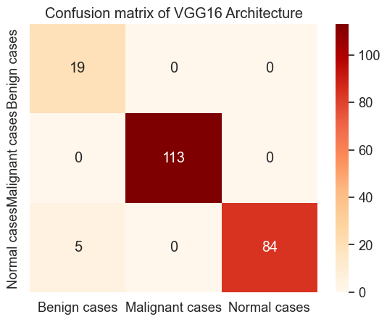

**Figure:** Confusion matrix of VGG16 Architecture

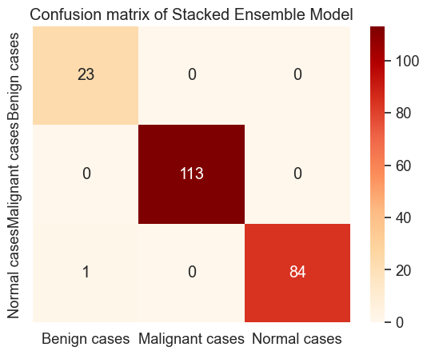

**Figure:** Confusion matrix of Stacked Ensemble Model